ESPACOMP advanced Implementation Science Masterclass

Organizing committee
Prof. dr. Bart van den Bemt, PhD, PharmD (Sint Maartenskliniek, Radboud university medical center, Netherlands)
Dr. Charlotte Bekker, PhD (Radboud university medical center, Netherlands)
Prof. Dr. Leah Zullig, PhD, MPH, (Duke University and Durham Veterans Affairs Centre for Health Services Research in Primary Care, USA)
Prof. Dr. Liset van Dijk, PhD, ( Nivel Utrecht, The Netherlands & University of Groningen)
Prof. Dr. Sabina De Geest, PhD, RN (University of Basel, Switzerland & KU Leuven, Belgium)

Introduction
Implementing evidence-based interventions into routine care is very difficult and needs strategies that address the complexity of systems of care, including patients / families, communities, individual practitioners, senior leaders and contextual factors. From the time evidence is generated to the time it becomes part of everyday practice takes often longer than 17 years. Although an increasing number of academic researchers acknowledge the importance of implementation research, historically, the research-to-practice gap has often been neglected. Traditionally research has focused on effectiveness and safety of an intervention with highly selected patients and selected contexts. Whether these findings translate into public health impact has typically received less attention. However, the ultimate impact of health innovations depends not only on the effectiveness of the intervention, but also on its successful implementation and sustainability in a variety of contexts.

Implementation science aims to facilitate the systematic uptake of research findings into routine practice, and, hence, to improve the quality and effectiveness of health services. This advanced workshop will build on former introduction course in implementation science and address several methodological building blocks of implementation science related to medication adherence interventions in greater depth.

Structure
Five webinars of each 2 hours over a period of three months. Each webinar starts with a theoretical lecture followed by small group work and plenary discussions. Participants are encouraged to actively participate in all discussions. For each webinar some preparatory work is provided consisting of reading materials and an assignment.

After the workshop, participants:
- Will have knowledge about theoretical background of implementation science
- Will be provided with tools to study the implementation of medication adherence interventions
- Will have practical hands on about application of fundamentals of implementation science to their own project
- Will be inspired by experiences of other participants
- Will go home with revived energy to implement adherence interventions

Learning methods
Interactive webinars, theoretical education, exercises, small group work.

Maximum number of participants: 15. Participants need to have basic knowledge about implementation science. Please submit a half page application letter addressing your experience with and knowledge about implementation science to Charlotte Bekker (charlotte.bekker@radboudumc.nl). For example, courses or lectures you have followed or what kind of IS research projects you have been involved in.

Registration: Participants can register via the ESPACOMP’s website https://www.espacomp.eu/product/workshop-1-2021-implementation-science-short-course/

Webinar date | Topic | Speaker(s)
- Introduction to Implementation Science
November 3rd, 2021  4-6 pm CET | Principles of Implementation Science and introduction to Basel Heptagon  Learning objectives:  - To describe sources of research waste and challenges in translation of high quality evidence in real-world settings  - To position implementation science among scientific methods  - To get insights in specific methodological consideration of implementation science using the Basel Heptagon of implementation science | Prof. dr. Sabina De Geest, University of Basel, Switzerland & KU Leuven, Belgium
- Implementation science theories, frameworks and models
November 24th, 2021  4-6 pm CET | How to select the most appropriate theoretical framework  Learning objectives:  - To understand the role of theories, models, and frameworks in supporting implementation science research  - To gain appreciate for the breadth of available implementation science theories, models and frameworks  - To conceptualize the process for identifying an appropriate implementation science theories, models or framework for a particular project | Leah Zullig, PhD, Duke University and Durham Veterans Affairs Centre for Health Services Research in Primary Care, USA
- Contextual analysis
December 15th, 2022  4-6 pm CET | To better understand and map the relevant characteristics of the setting in which the intervention will be implemented. Contextual information contributes to effective intervention co-design and informs the choice of contextually relevant implementation strategies.  Learning objectives:  - To know what context is and why it relevant  - To know what context analysis is and why it is relevant  - To understand how to plan and conduct a context analysis | Dr Lisa M Pfadenhauer, LMU Munich  Juliane Mielke, UNIBAS
- Approaches to Measuring Outcomes in Effectiveness-Implementation Hybrid Designs
January 12th, 2022  4-6 pm CET | Combine the evaluation of an intervention’s effectiveness and the outcomes of implementation efforts  Learning objectives:  - Understand the rationale for and basic structure of three types of effectiveness-implementation hybrid designs  - Understand approaches to measuring effectiveness and implementation outcomes across three types of hybrid designs  - familiarize with novel implementation evaluation frameworks designed to facilitate the measurement of equity in the delivery (and receipt) of evidence-based practices | Prof. dr. Geoffrey Curran, University of Arkansas for Medical Sciences, USA
- Implementation strategies
February 2nd, 2022  4-6 pm CET | Facilitate the adoption, implementation, sustainability and scaling up of specific interventions, programmes or practices  Learning objectives:  - To recognize and compare available implementation strategies of different overviews/clusters  - To select and develop implementation strategies based on the previously conducted contextual analysis (tailoring)  - To evaluate implementation strategies on feasibility (in a small-scale setting) | Dr. Rosella Hermens and Julie Swillens, MSc, Radboudumc, Netherlands

The course will follow the Basel Heptagon¹⁾ that describes seven domains to be considered during an implementation science project (see Figure below).

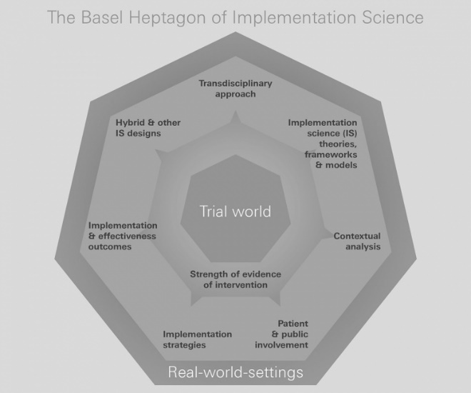

¹⁾ De Geest et al Swiss Medical Weekly 2020;150:w20323; doi:10.4414/smw.2020.20323

